**DAILY ONLINE ACTIVITIES SUMMARY**

|  |  |  |  |  |  |  |  |  |
| --- | --- | --- | --- | --- | --- | --- | --- | --- |
| **Date:** | **15/07/2020** | | | | | **Name:** | **RITIKA KULKARNI** | |
| **Sem & Sec** | **4th SEM. & ‘B’ SEC.** | | | | | **USN:** | **4AL19CS403** | |
| **Online Test Summary** | | | | | | | | |
| **Subject** | | **Operating System** | | | | | | |
| **Max. Marks** | | **30** | | **Score** | | | **--** | |
| **Certification Course Summary** | | | | | | | | |
| **Course** | **Programming for Everybody (Getting Started with Python)** | | | | | | | |
| **Certificate Provider** | | | **Coursera** | | **Duration** | | | **7 weeks** |
| **Coding Challenges** | | | | | | | | |
| **-----** | | | | | | | | |
| **Status : --** | | | | | | | | |
| **Uploaded the report in Github** | | | | | **Yes** | | | |
| **If yes Repository name** | | | | | **-----** | | | |
| **Uploaded the report in slack** | | | | | **Yes** | | | |

**Online Test Summary: 18CS43 Descriptive IA test was scheduled from 9:00 AM to 10:15 AM.The portion for the IA was 1st module there were 4 questions and each question carried 7.5 marks.**

**Online Certification course Summary: In today's session I learnt Python as a language. Python was not named for a snake even though we use the snake motif all the time. It turns out that Python was named for Monty Python's Flying Circus. And the reason was that Guido was trying to capture an air of play.**

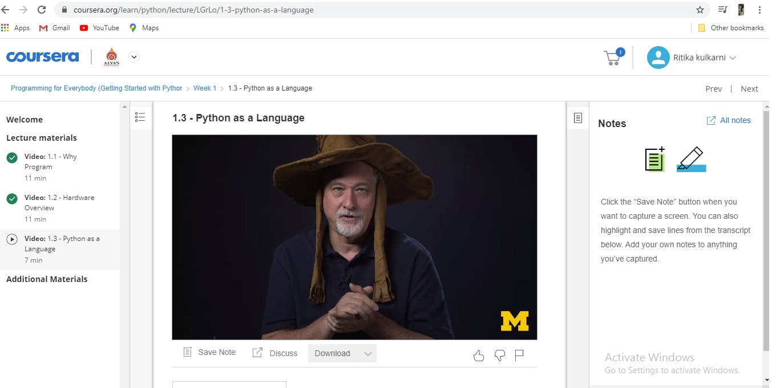

**Online Coding Summary: Didn’t receive any program.**